**Project Management API Lifecycle**

**Figure 1**

*Lifecycle*

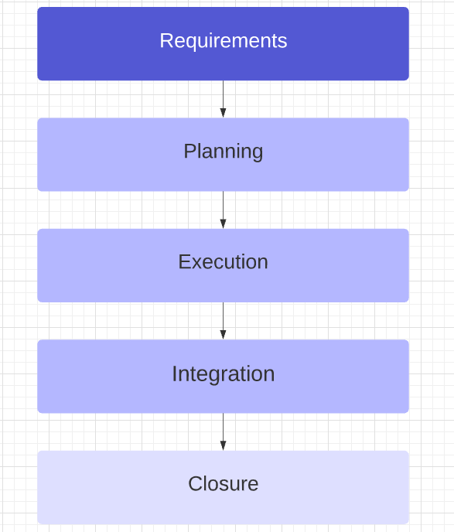

*Note.* Created in <https://lucid.app>.

The product lifecycle (see Figure 1) will be composed of five phases. In the requirements phase, the client and project team will convene and the product will be defined. The planning phase forms the project foundation, isolating the schedule, acquiring resources, and establishing workflows. Approval is required from stakeholders before advancing to the next phase. During execution, the implementation of product components will occur and as milestones are met or issues encountered, progress will be communicated as appropriate to stakeholders. Subsequently in the integration phase, the product will be assembled and thoroughly tested for any exceptions or failures. Lastly, during closure the project manager will meet with assurance staff and final reports will be generated in addition to other documentation for knowledge transfer.